Belize – Central American Gem with small distances & long species lists
From Mayan Tropical Forests up to Mountain Pine Ridge
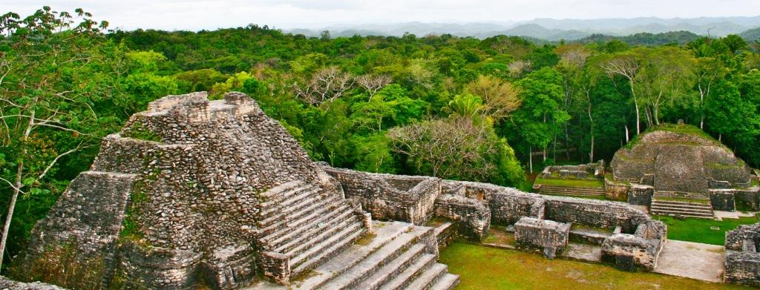

Belize has all the potential to become one of the emerging birding, butterfly & wildlife destinations in Central America. The country was formerly known as British Honduras, has a population of just 0.3 million people and a huge portion of its land covered by lush forests. There are several National Parks and other protected areas, plus some prime Mayan Archeological sites which makes the country a perfect Birding, Wildlife & Culture destination. Add to this the World’s second largest Coral Reef with about thousand cays which offer great relaxation with some snorkeling.
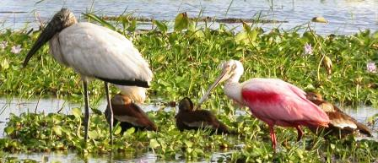
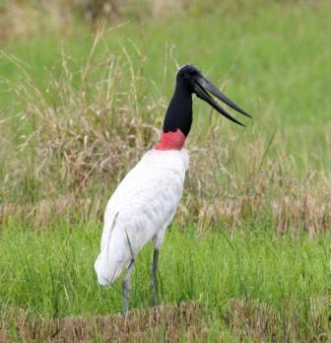
Day1
Start from London
Day2
Arrive to Belize City about midday
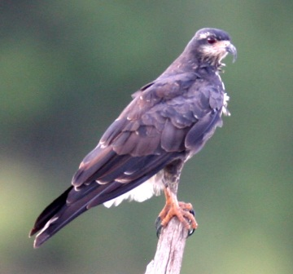
After arriving to Belize City we have a very short drive to Crooked Tree Wildlife Sanctuary, which is surely the best wetland birding area in perhaps not just Belize, but neighbouring countries as well. No wonder that its area protected by the Ramsar Convention and the Audobon Society as well, especially for the sake of the giant Jabiru Stork which we hope to see as well. They simply call it Birders’ Heaven.
After checking in we go on a boat trip to discover the waterbirds around. Depending on the water level we will see different things, but there is no doubt that birds will be everywhere from the common Herons & Egrets like Great Blue & Little Blue Heron, Green & Tricolored Heron, Black-crowned & Yellow-crowned Night Heron, Snowy-, Great & Cattle Egret till the more elusive ones like Agami Heron, Bare-throated Tiger Heron or the funny-looking Boat-billed Heron. At the edges among vegetation we will look for Grey-necked Wood Rail, Purple Gallinule, Common Moorhen, Northern Jacana, Least Bittern & Ruddy Crake and with some luck even Sungrebe, while on the open water American Coot, American Wigeon, Blue-winged Teal, Lesser Scaup, Northern Shoveler & Pied-billed Grebe is possible.
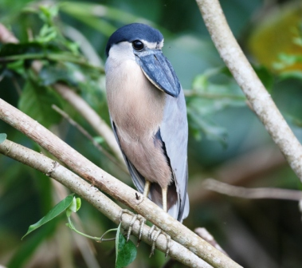
Kingfishers will be represented by Amazon & Green Kingfisher, Belted & Ringed Kingfisher and perhaps we can find American Pygmy Kingfisher as well.
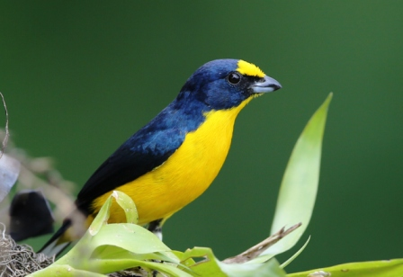
It will be very easy to spot larger birds if they around, like American White Pelican or the Barbie-coloured Roseate Spoonbill, but the real giant to look for the Jabiru Stork, a local breeder in the area.
We can also add some of the following species to the list: Limpkin, White & Glossy Ibis, Anhinga, Southern Lapwing, Wood Stork, Black-bellied Whistling Duck, Black-necked Stilt, Solitary-, Least & White-rumped Sandpiper, Lesser Yellowlegs.
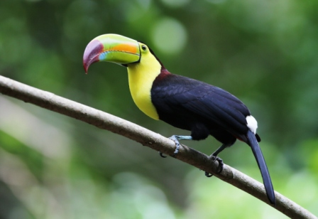
We will check the sky for raptors such as Black-collared Hawk, Snail Kite, Common & Great Black Hawk, Gray Hawk, Gray-headed Kite, Black- , Turkey & Lesser Yellow-headed Vulture, Peregrine Falcon, Roadside Hawk, White-tailed Hawk & Snail Kite, oh, and of course Osprey.
At the bushy edges we will look for Blue-gray Gnatcatcher, Prothonotary Warbler & Yellow Warbler.
Aside from birds, the sanctuary's rich wildlife includes crocodiles, monkeys, turtles and iguanas. The latter ones are represented by Black, Brown and Green, while Jesus Christ Lizards can be spotted as they run across smaller water-bodies.
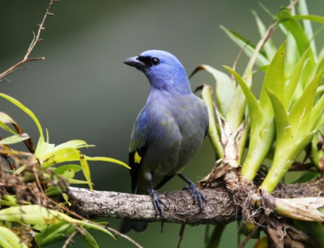
Night at Birds’ Eye View or Black Orchid Lodge
Day3
Today we go on a full day tour to Lamanai, which are the most famous Mayan Ruins in Northern Belize. Although it would be possible to reach the site with a long and exhausting dirt-road drive (which we did about 10 years ago when we first discovered the area), but it is much more pleasant to visit this site with a boat. Although the boat ride itself is not primarily about birding, still we have a chance to pick up some of the species we might have missed during the previous day.
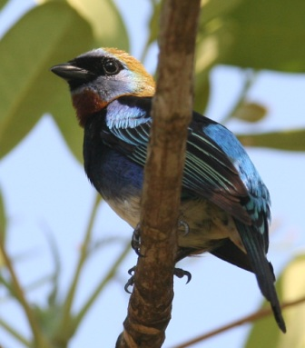
When we arrive to the site it will be obvious that once it was a very important centre for the Mayans. It was a busy city for more than 3000 years till the arrival of the Spanish. Most of the buildings are still not restored, but from the top of the High Temple you can have an incredible canopy view. The surrounding giant trees offer food and perch for exotic species, such as Collared Aracari, Keel-billed Toucan, White-fronted & Red-lored & Yellow-lored or Yucatan Parrot.
This will be perhaps the first place where we will hear the incredible voice of the World’s loudest animals, the Howler Monkeys; these will be the Yucatan Black versions.
Several species look for food on tree-trunks and branches include Acorn-, Red-vented-, Golden-fronted-, Lineated & Pale-billed Woodpecker, plus Ivory-billed & Northern Barred Woodcreeper.
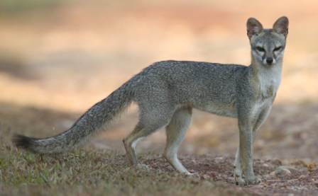
If we can find an ant-swarm then it will easy to see Red-throated & Red-crowned Ant-tanagers, Grey-hooded Tanager & perhaps even Mexican Antthrush as well.
Other colourful species to look for include Buff-throated Saltator, Blue Bunting, Black-cowled Orioles, Blue-crowned or Diademed Motmot.
Night at Birds’ Eye View Lodge or Black Orchid Lodge
Day4
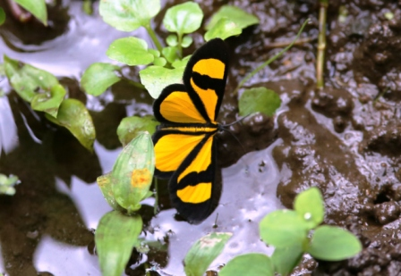
In the morning we will birding around close to our accommodation at a scrubby, savannah-type of vegetation to find such colourful & interesting birds as Vermillion Flycatcher, Fork-tailed Flycatcher, Aztec or Olive-throated Parakeet, American Redstart, Hooded Oriole, Indigo Bunting. This is also a great area to find some of the Yucatan endemics such as Yucatan Jay or Yucatan Woodpecker and other species like Boat-billed Flycatcher, Canivet’s Emerald, Groove-billed Ani, Grace’s Warbler and Red-winged Blackbird.
Later on we travel towards the Guatemalan border across agricultural fields of Memmonite communities to our new accommodation at Chan Chich Lodge.
We will cross the Rio Bravo Conservation area and enter into a huge, private protected area where any kind of hunting by humans is prohibited, so there is a good chance to see crossing groups of colourful regional endemic Ocellated Turkeys. Due to the protection, natural hunters gaining a strength here, building healthy populations of several cats, such as Puma/Mountain Lion, Jaguar, Jaguarundi, Margay & Ocelot. We have a good chance to find at least the footprints, but with some luck during an evening tour we might get a glimpse as well of one of these cats or at least a Grey Fox.
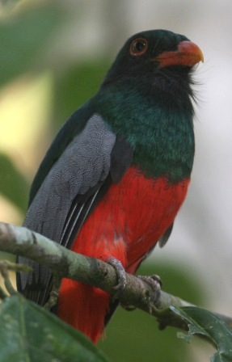
Night at Chan Chich Lodge
Day5
We spend the whole day birding at Chan Chich area. We will look for new species at different habitats, perhaps first in the forest and later on in the garden around our accommodation.
Excellent forest species here include the hard to find Tody Motmot, the cheerfully whistling Thrushlike Schiffornis, the sometimes surprisingly tame, otherwise elusive Great Tinamu.
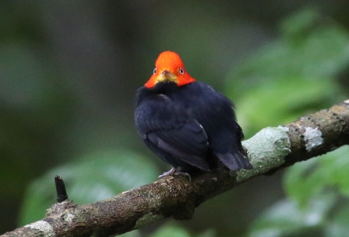
Smoky-brown, Black-cheeked, Golden-olive, Chestnut-colored, Lineated and Pale-billed Woodpecker all common in the area.
In the garden or nearby we should find Baltimore-, Orchard & Black-cowled Oriole, Melodious & Red-winged Blackbird, Grey-throated Chat, several Tanager species, Slaty-tailed Trogon, Montezuma Oropendola, a long list of Warblers & Vireos.
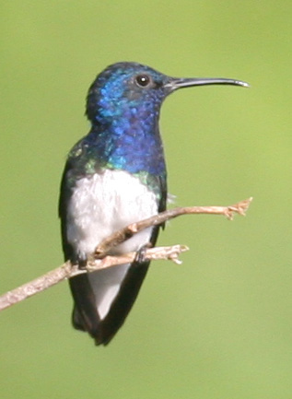
Later during the day as temperature rises Raptor activity will be stronger. It should be easy to pick a circling adult King Vulture, while colourful Kites to check include White-tailed, Swallow-tailed & Plumbeous Kite. Hawks also represented strongly by White-, Gray-, Great Black- & Short-tailed Hawk. We hope to compare Black & Ornate Hawk-Eagle as well, both nesting in the area.
Night at Chan Chich Lodge
Day6
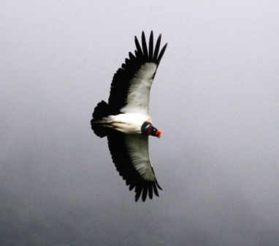
We have another great morning birding at Chan Chich before we leave the area.
We try to complete our list of more than a dozen species of Hummingbirds, which were recorded in the area and we will most likely see Long-billed or Western Long-tailed Hermit, Stripe-throated Hermit, Scaly-breasted Hummingbird, White-necked Jacobin, Purple-crowned Fairy and from the Amazilia species White-bellied Emerald & Rufous-tailed Hummingbird.
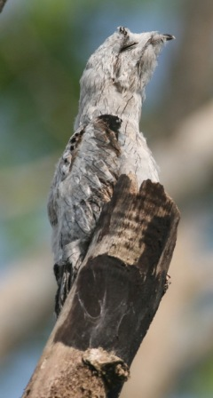
As we leave our fantastic base on the way we should bump on the road a Crested Guan or a Great Curassow.
There will be a complete change in habitats, since from the lowland tropical forest we will gradually travel to Mountain Pine Ridge area. It is not at all at extremely high elevation, but it is completely different mainly because the majority of the reserve is on a granite massif and some limestone mainly covered by Honduras pine forest and broadleaf forest. The climate is subtropical and there are a couple of species which much harder or can not be found elsewhere, such as the regionally endemic Rusty Sparrow which we will search among the pines. We will look for Rufous-capped Warbler as well.
Night at Mountain Pine Ridge Reserve at one of the lodges, depending on group size
Day7
Today we continue to discover the huge protected area with its several trails visiting both tropical broad-leaf forests and pine woods as well.
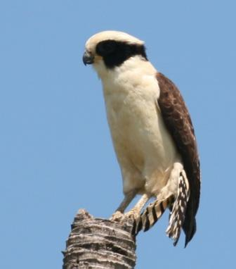
Birding in the Mountain Pine Ridge should result Azure-crowned Hummingbird, Black-cheeked Woodpecker, Golden-hooded Tanager, Yellow-backed & Yellow-tailed Oriole.
Red-lored Parrot gives a clear sign with its characteristic, loud sound which is strongly different from Mealy Parrot, and we usually hear first Scaly-throated Foliage-gleaner as well. Acorn Woodpecker, Yellow-faced Grassquit and Black-headed Siskin is quite localized here as well.
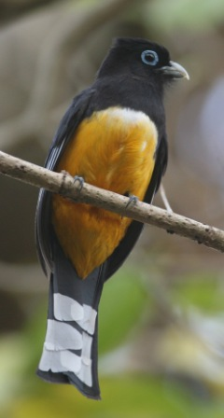
Hepatic Tanager, Green Jay, Ovenbird could be new species here and with some luck we might find Scaled Pigeon as well.
We will visit the famous 1000- feet Cascade which is one of the largest waterfalls in Central America. It is not just a perfect place to cool down a bit, but a breeding area for the otherwise scarce Orange-breasted Falcon. This is also a good site to look for other raptors, such as a circling Solitary Eagle or a spectacular King Vultures.
During one of the evenings we will try to localize a Stygian Owl, which is quite a rarity or hard to find species usually.
Night at Mountain Pine Ridge Reserve
Day 8
This day we will spend with one of the best Nature & Culture combinations when we visit Belize’s most famous and perhaps most spectacular Mayan site, Caracol.
We might decide to go really early to give a chance to get a glimpse of one of the rare cats, such as a Puma, Jaguar, Ocelot or Jaguarundi, but of course we have higher chance for other mammals such as White-nosed Coati or Collared Pecari. This is the time when very rarely Black-and-white Owl can be heard as well.
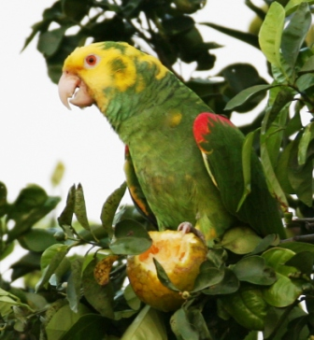
Caracol was once a huge Mayan city with over a population of 100thousand, so no wonder just part of the tens of thousands of buildings and structures unearthed. You can have an incredible view of the surrounding vast forests from one of the main buildings. There is a long list of raptors which are possible to spot here, very rarely even Harpy Eagle, but more likely we will find Ornate Hawk-Eagle & Grey Hawk.
Walking among the scattered ruins we check the huge trees for Chestnut-coloured-, Lineated & Pale-billed Woodpecker, plus Ivory-billed & Northern Barred Woodcreeper. A nice new species would be the localized Keel-billed Motmot & Rose-throated Tanager and Buff-throated Foliage-gleaner.
Night at Mountain Pine Ridge Reserve
Day9 & Day10
After a last birding in the morning around the lodge we travel back to the Caribbean Seaside close to Belize City, spend 3 days/2nights at the beach, with optional programmes either visit one of the beautiful cays or the nearby Cockscomb Basin Forest Reserve, which is protecting a very bird-rich forest & a strong Jaguar population.
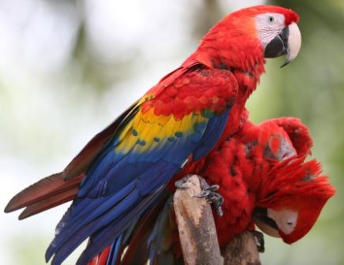
This is a good place to complete our list, since the bird diversity is high and perhaps we will find some species which we have missed before, such as the critically endangered Yellow-headed Parrot, or the beautiful Collared Trogon, the curious Barred Antshrike, the characteristic White-collared Manakin, the strikingly coloured Passerini’s Tanager.
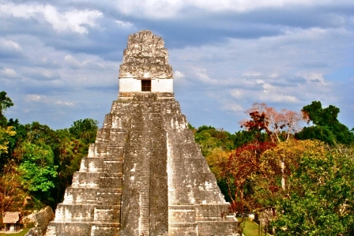
Plain Chachalaca should be easy and the forest gives another chance for Crested Guan & Thrush-like Schiffornis. Another new species can be Chestnut-sided Warbler and Orange-billed Sparrow.
Day11 flight back to Cancun & London
Day12 arrival to London
Guatemala extension
It is possible to continue on Day9 to Guatemala for an extraordinary 6nights/7days extension with 2 special bases, one in the middle of the Mayan Biosphere Reserve and another in the World Famous Mayan Archeological site of Tikal. Please note that each season regional local flights between Flores/Tikal, Guatemala & Cancun, Mexico change a lot, so it is necessary to double check availability before booking the extension and buying the main London-Cancun-London ticket.
Days9-11 3 nights and days in the middle of the Mayan Biosphere Reserve at a place where Tapirs & Jaguars roam, Lovely Cotinga is around and Scarlet Macaws fly around.
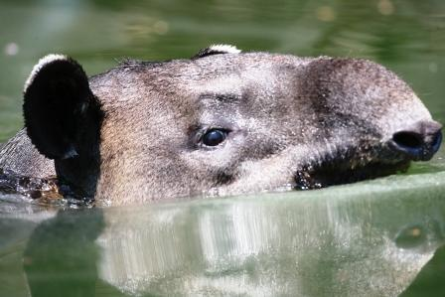
Days12-14 3 nights and days at the World Famous Mayan Archeological site of Tikal
Day15 flight Tikal to Cancun, relax at the Caribbean beach
Day16 leisure time till the flight back to London
Day17 arrive back to London
ACCOMMODATIONS:
There will be a great variety of different types of accommodations we will use during this tour including birdwatching group & bird-oriented lodges & top quality jungle hotels.
Belizean extension: resort at the Caribbean seaside and/or at one of the cays
Guatemala extension: 3 nights in the jungle; research station rooms were converted into guest-rooms & 3 nights at Tikal; the most unique ancient Mayan City surrounded by Biosphere Reserve. At each accommodation the main focus is to be in the middle of the best possible birding & wildlife area.

