Galapagos Cruise – Ultimate Nature Experience
Ecuador, 9 days

Put together your own group and receive significant discounts!
The cherry on top of any Ecuador visit is our 8-day-long Galapagos cruise, which visits the best parts of the enigmatic archipelago. We have carefully selected the best available birding route to get the most out of it, so we visit several islands with numerous birding sites witnessing various landscapes and abundant wildlife. This is truly an ultimate nature experience, a dream of any nature enthusiast!
Please note that the programme of visiting different islands can be changed by local authorities without prior notice or due to weather changes!
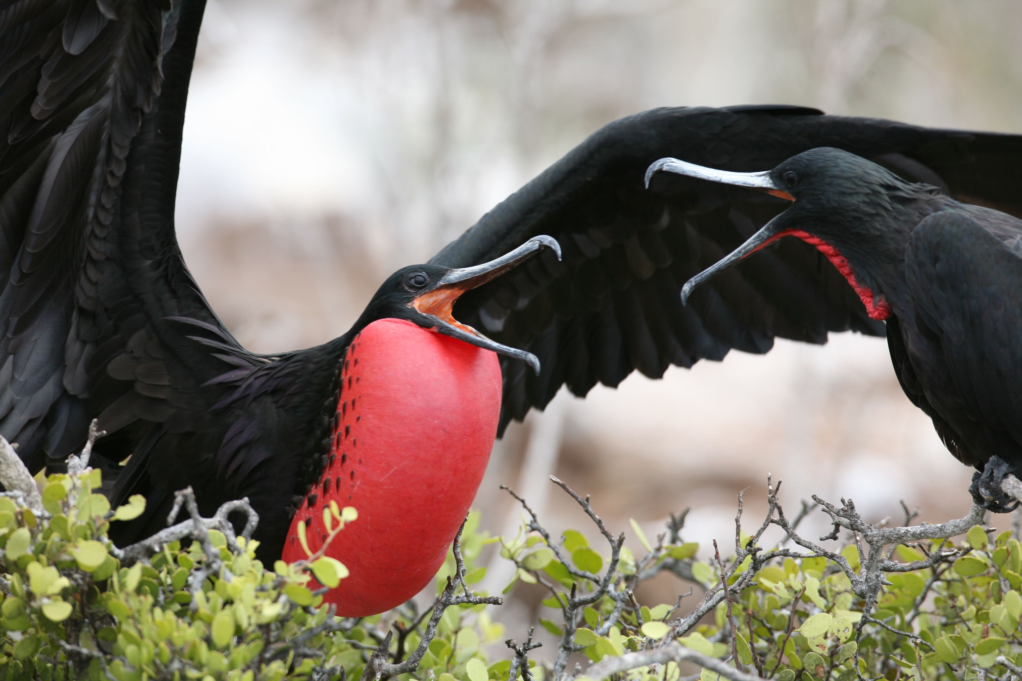
Fact File
- 8 days cruising
- start and finish in Quito with a flight to/from Isla Baltra, Galapagos
- using a comfortable Galapagos cruise ship to discover at least 10 islands
Highlights
- visiting the 10 best spots of the Galapagos Islands
- wide variety of amazing birds, reptiles and mammals with great photo opportunities
Accommodation
2 nights at Quito, colonial capital of Ecuador
7 nights on board of a cruise ship, ideal for small groups
1 overnight flight
Itinerary
1 | Arrival to Quito, short transfer to the hotel. Depending on the arrival time we might spot the first local birds, such as Vermillion Flycatcher, Rufous-collared Sparrow, Black-tailed Trainbearer and Sparkling Violet-Ear.
2 | We depart from Quito and fly to Isla Baltra, followed by a short transport to Santa Cruz Island, from where we start our Galapagos Birding Cruise in quest of birds and other natural beauties. First we visit two small beaches, the Bachas, a favorite nesting site for sea turtles. Behind one of the beaches there is a small brackish water lagoon, where occasionally flamingos, Black-necked Stilt, Whimbrel and other species can be found.
3 | We visit Plazas Islands, two small islets a short distance from the East Coast of Santa Cruz. The principal attractions here are land iguanas, sea lions and Swallow-tailed Gulls. Also we might see Audubon’s Shearwater, Red-billed Tropicbird, Magnificient Frigatebird and Brown Pelican gliding past the cliff. The small bay on Santa Fe (Barrington) Island's northeast coast is an extremely picturesque place. There are two different trails at this site, one leads to a scenic viewpoint on top of a cliff where it is possible to find land iguanas. A particular attraction is the unusually tall forest of prickly Opuntia cactus. Of course several seabirds will be around as well.  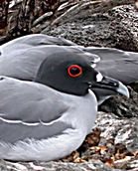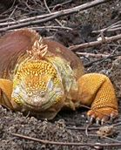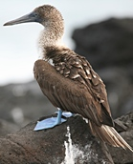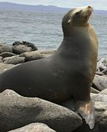
4 | We start with a visit at Bahia Gardner located on Espanola/Hood Island to observe sea lions and also for relaxing and swimming. During the afternoon our next stop will be at Punta Suarez, which is sustaining one of the most varied colonies of seabirds in the Galápagos. Waved Albatross, Masked and Blue-footed Boobies nest here in big colonies. There is also an attractive blow-hole, where water spouts up to 50-75 feet into the air according to the intensity of the surf. There are other interesting birds to look for on the island such as the local endemic Hood Mockingbird, Warbling Finch, Galapagos Hawk, Large Cactus Finch, Swallow-tailed Gull, Red-billed Tropicbird and many more.
5 | Punta Cormoran on Santa Maria/Floreana Island offers probably one of the largest and best flamingo lagoons in the Galapagos. There are various species of shorebirds to be seen including Black-necked Stilt, White-cheeked Pintail, Willet, Wimbrel etc. Post Office Bay is a historical site, where a wooden barrel was placed in the 18th century by the crew of a whaling ship. It has been used since by mariners and tourists as a post office. This site was the landing area for some of the first colonists as well.
6 | Today we return to Santa Cruz Island to visit the famous Charles Darwin Interpretation Center. It is not just a great place to observe and appreciate natural wonders, it is also interesting to learn how the protection and conservation of the islands are carried out. The principal attractions are the National Park information center, Van Staelen Exhibition Hall, Breeding and Rearing Center for young tortoises and other adult Galapagos Tortoises in captivity. During the afternoon we will visit the Highlands of Santa Cruz.
7 | Rábida/Jervis Island has a striking dark red color due to the high content of iron in the lava. Behind the beach there is a picturesque salt-water lagoon, where White-cheeked Pintail provides a beautiful view at the southeastern cliffs. The island’s 367m high volcanic peak is covered by palo santo trees.  Bartolome is a small barren island, located in Sullivan Bay off James Island. The moon-like landscape provides the most scenic panorama in the archipelago. We may also swim and snorkel on a beautiful beach. Multicolored fish and occasionally Galapagos Penguins may be seen at the base of the tall pinnacle rocks.
8 | Genovesa/Tower Island is an outlying island, so it is less visited and is only included in some of the cruises. It is well worth the long trip, because it is the best place to see colonies of Red-footed and Masked Boobies. Swallow-tailed Gulls, Red-billed Tropicbirds, Great Frigatebirds and thousands of Wedge-rumped Storm Petrels are present as well. We can spot Galapagos Doves and a local endemic subspecies of Short-eared Owl as well. This island gives a second chance for the Large Cactus-Finch and among the finches we will look for the Sharp-beaked Ground-Finch as well.
9 | North Seymour Island is a small island well worth visiting for its wildlife. The vegetation is mainly low and bushy and holds the largest colony of Magnificent Frigatebirds in the Galapagos. There is also a large population of Blue-footed Boobies. Additional attraction is that at the coastline resides a colony of playful sea lions.  Mosquera Islet is a small, flat, sandy island almost devoid of vegetation. This is one of the best places to observe sea lions. It is also a good place to find herons, Lava Gulls and coastal birds.  We reluctantly finish our cruise, say goodbye to our ship and crew and transfer to Isla Baltra’s airport for our flight back to Quito where we spend 1 night.  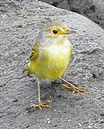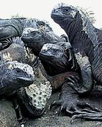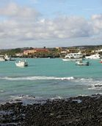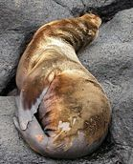
10 |  | Flight back to London or continue on our Ecuador Highland Special tour. Depending on the flight schedule there is a possibility of a last morning birding by visiting a nearby volcano to search for local species or look around in the colonial centre of the capital city.
11 | Overnight flight, arrival home.
Put together your own group and receive significant discounts!

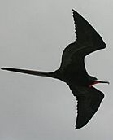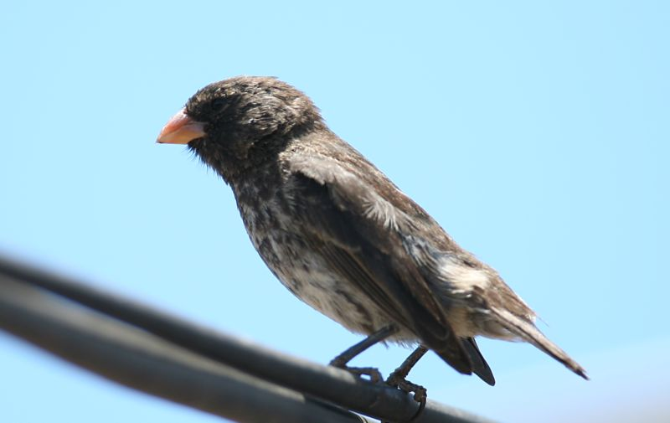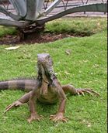
Please note that the route of the cruise can be changed without advanced notice! Deadline for signup and payment is different from other tours.

The Highland Special; NW & East Cordilleras
Ecuador, 9 days

Put together your own group and receive significant discounts!

Nowhere else on earth can you find such a high biodiversity in such a small place like Ecuador. Although it is the second smallest country in South America it boasts of an extraordinary richness of birds, well over 1600 species. Birding is easy and relaxed thanks to short distances, comfortable lodges and an incredible abundance of species. Colourful Hummingbirds, Tanagers, Toucans, Trogons, Quetzals, Barbets, Motmots, Cotingas abound in the Highlands, while secretive and mythical Antpittas, Ant-thrushes, Woodcreepers and Tapaculos are also seen in mixed feeding flocks in the cloud forest. Enigmatic species such as Andean Cock-of-the-Rock, hiding Oilbird, highly specialized Torrent Duck or several species of Antpittas can also be found. We hope to see at least 400 species during our relaxed holiday.

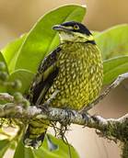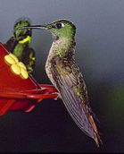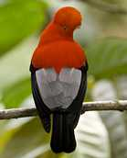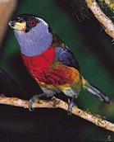

Fact File
- 9-day land tour of NW and East Cordilleras,
- start and finish in Quito, colonial capital,
- using just 3 accommodations to maximize visited habitats and possible species
Highlights
- close to 1600 bird species out of which we hope to get around 1 quarter of it
- incredible variety of habitats from Pacific coast through temperate subtropical forest up to the Paramo of the Andes dotted with high volcanoes and down to tropical rainforests
- 4-500 bird species, up to 70 tanagers, 60 hummingbirds, Toucans, Trogons, Quetzals, Barbets, Tapaculos, Andean Cock-of-the-Rock, Oilbird, Torrent Duck, Antpittas
Accommodation
2 nights (1st and 7th) at Quito,
3 nights at Bellavista, NE Cordilleras
2 nights at San Isidro or Guango Lodge, Eastern Cordilleras
1 overnight flight
Itinerary
1 |  |  | Arrival to Quito, short transfer to the hotel. Depending on the arrival time we might spot the Vermillion Flycatcher, Rufous-collared Sparrow, Black-tailed Trainbearer and Sparkling Violet-Ear.
2 |  |  | Early morning start and travel to the NW Highlands, birding en-route at Yanacocha area and on the Nono Road. Each stop we make on our way will surprise us with Empress Brilliant, Collared and Brown Inca, Green-fronted Lancebill and Booted Racket-tail, Hoary, Golden-breasted and Black-breasted Puffleg. There is a chance to find some of the Antpitta species like Undulated and Rufous Antpitta. Other potential interesting species include Andean Guan, Bar-bellied Woodpecker, Barred Fruiteater, Rainbow-bearded, Thornbill and Black-chested Mountain-Tanager.  Roadside rivers can hold Torrent Duck, other waters Fasciated Tiger-Heron, while the skies will be ruled by Plain-breasted Hawk, Black-chested Buzzard Eagle, Black-and-chestnut Eagle and Ornate Hawk-Eagle.  Finally we end up at our charismatic lodge, Bellavista where we will be based for 3 nights. Each evening we can look in the premises of the lodge for Common Potoo, Lyre-tailed or Swallow-tailed Nightjar and Rufous-bellied Nighthawk.  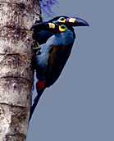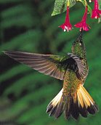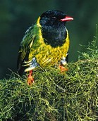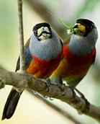
3 |  |  | We spend a full day around Bellavista in search of Toucan Barbet, Masked Trogon, Plate-billed Mountain Toucan and flocks of Tanagers such as Metallic Green, Flame-faced, Silver-throated, Grass Green, Orange-eared, Golden-naped, Fawn-breasted, Blue-capped and Blue-winged Mountain Tanager.  Hummingbird feeders attract Brown and Collared Inca, Tawny-bellied Hermit, Green and Sparkling Violetears, Western and Andean Emeralds, Fawn-breasted Brilliant, Speckled Hummingbird, Buff-tailed Coronet, Gorgeted Sunangel, Purple-bibbed Whitetip, Booted Racket-tail and Purple-throated and White-bellied Woodstars. Some of the sought-after and often seen species around the lodge include Beautiful Jay, White-faced Nunbird, Chestnut-crowned and even Giant Antpitta, Ocellated Tapaculo, Golden-headed and Crested Quetzal, Plushcap, the localised Tanager Finch and the incredible Andean Cock-of-the-Rock.  Spillman’s and Narino Tapaculos, Green-and-black Fruiteater, Tri-coloured Brush-Finch, Southern Yellow Grosbeak, Long-tailed Antbird, Olivaceous Piha, Turquoise Jay, Masked and White-sided Flowerpiercers, Andean Solitaire, Black-crested and Three-striped Warblers, White-tailed and Rufous-winged Tyrannulets are encountered quite regularly as well.
4 |  |  | After a very early start today we travel to the World famous Mindo Valley. Among many others here we will visit “la Paz de las Aves” which is a great place to take photos of Giant Antpittas. The cloudforests of the Mindo Valley Reserve are home to a huge variety of birds including Velvet-Purple Coronet, Rufous-breasted Ant-thrush, Long-wattled Umbrellabird, Club-winged Manakin, Scaled Fruiteater, Yellow-collared Chlorophonia, Toucan Barbet, Choco Toucan, Golden-headed Quetzal, Crimson-rumped Toucanet, Pale-mandibled Aracari and Flame-faced, Golden-naped, Golden, Black-capped and Beryll-spangled Tanagers .  Later on we visit one of the finest sites in all of Ecuador at Milpe. This is a great place for plenty of the Chocó endemics such as Choco Toucan, Choco Screech-Owl, Choco Trogon and many more.  Los Bancos is another site where many sought-after and highly localised endemics occur, including Guayaquil Woodpecker, Pacific Hornero, Moss-backed Tanager and Pale-mandibled Aracari.
5 |  |  | Birding in the morning around Bellavista and later on the way around Alambi will be a great way to say goodbye to this amazing birding paradise. During the afternoon we have a long drive, short birding stops and finally we arrive to San Isidro, Eastern Cordilleras.
6-7 |  |  |  | We will visit some of the lower slopes of Antisana volcano for Andean Condor, Carrunculated Caracara, Andean Lapwing, Aplomado Falcon, Andean Gull, Ecuadorian Hillstar and Black-billed Shrike-Tyrant.  We will drive through Papallacta Pass, stopping at suitable birding sites trying to find Noble Snipe, Rufous-bellied Seedsnipe and Tawny Antpitta. Before leaving this spectacular area we also spend some time at Guango and San Isidro. We hope to see Scarlet-bellied, Lacrimose, Buff-breasted and Hooded Mountain-Tanagers, Grey-hooded Bush-Tanager, while hummingbirds will be represented by Mountain Velvetbreast, Sword-billed Hummingbird, Tourmaline Sunangel, Mountain Avocetbill, Golden-breasted and Glowing Pufflegs, White-bellied and Gorgeted Woodstars.  Close to our accommodation there are good places to search for several additional species such as Capped Conebill, Lacrimose Mountain-Tanager, Plain-tailed Wren, Chestnut-bellied Thrush, Rufous-breasted Flycatcher, White-bellied Antpitta, White-capped Tanager, White-rimmed Brush-Finch, Blackish, Ash-coloured and Equatorial Rufous-vented Tapaculos, Rufous-breasted Chat-Tyrant, Smoky Bush-Tyrant, Rufous-crowned Tody-Tyrant and many more.  Finally we return back to Quito for one night.
8 |  | We return to Quito airport for your flight back home. Depending on the flight schedule there is a possibility of a last morning birding or a visit in the colonial centre of the city.
9 | Overnight flight, arrival home

Put together your own group and receive significant discounts!

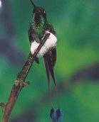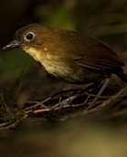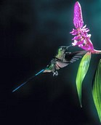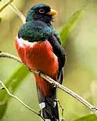
Photos: © Muray Cooper

