Galapagos Cruise – Ultimate Nature Experience
Ecuador, 9 days

Put together your own group and receive significant discounts!
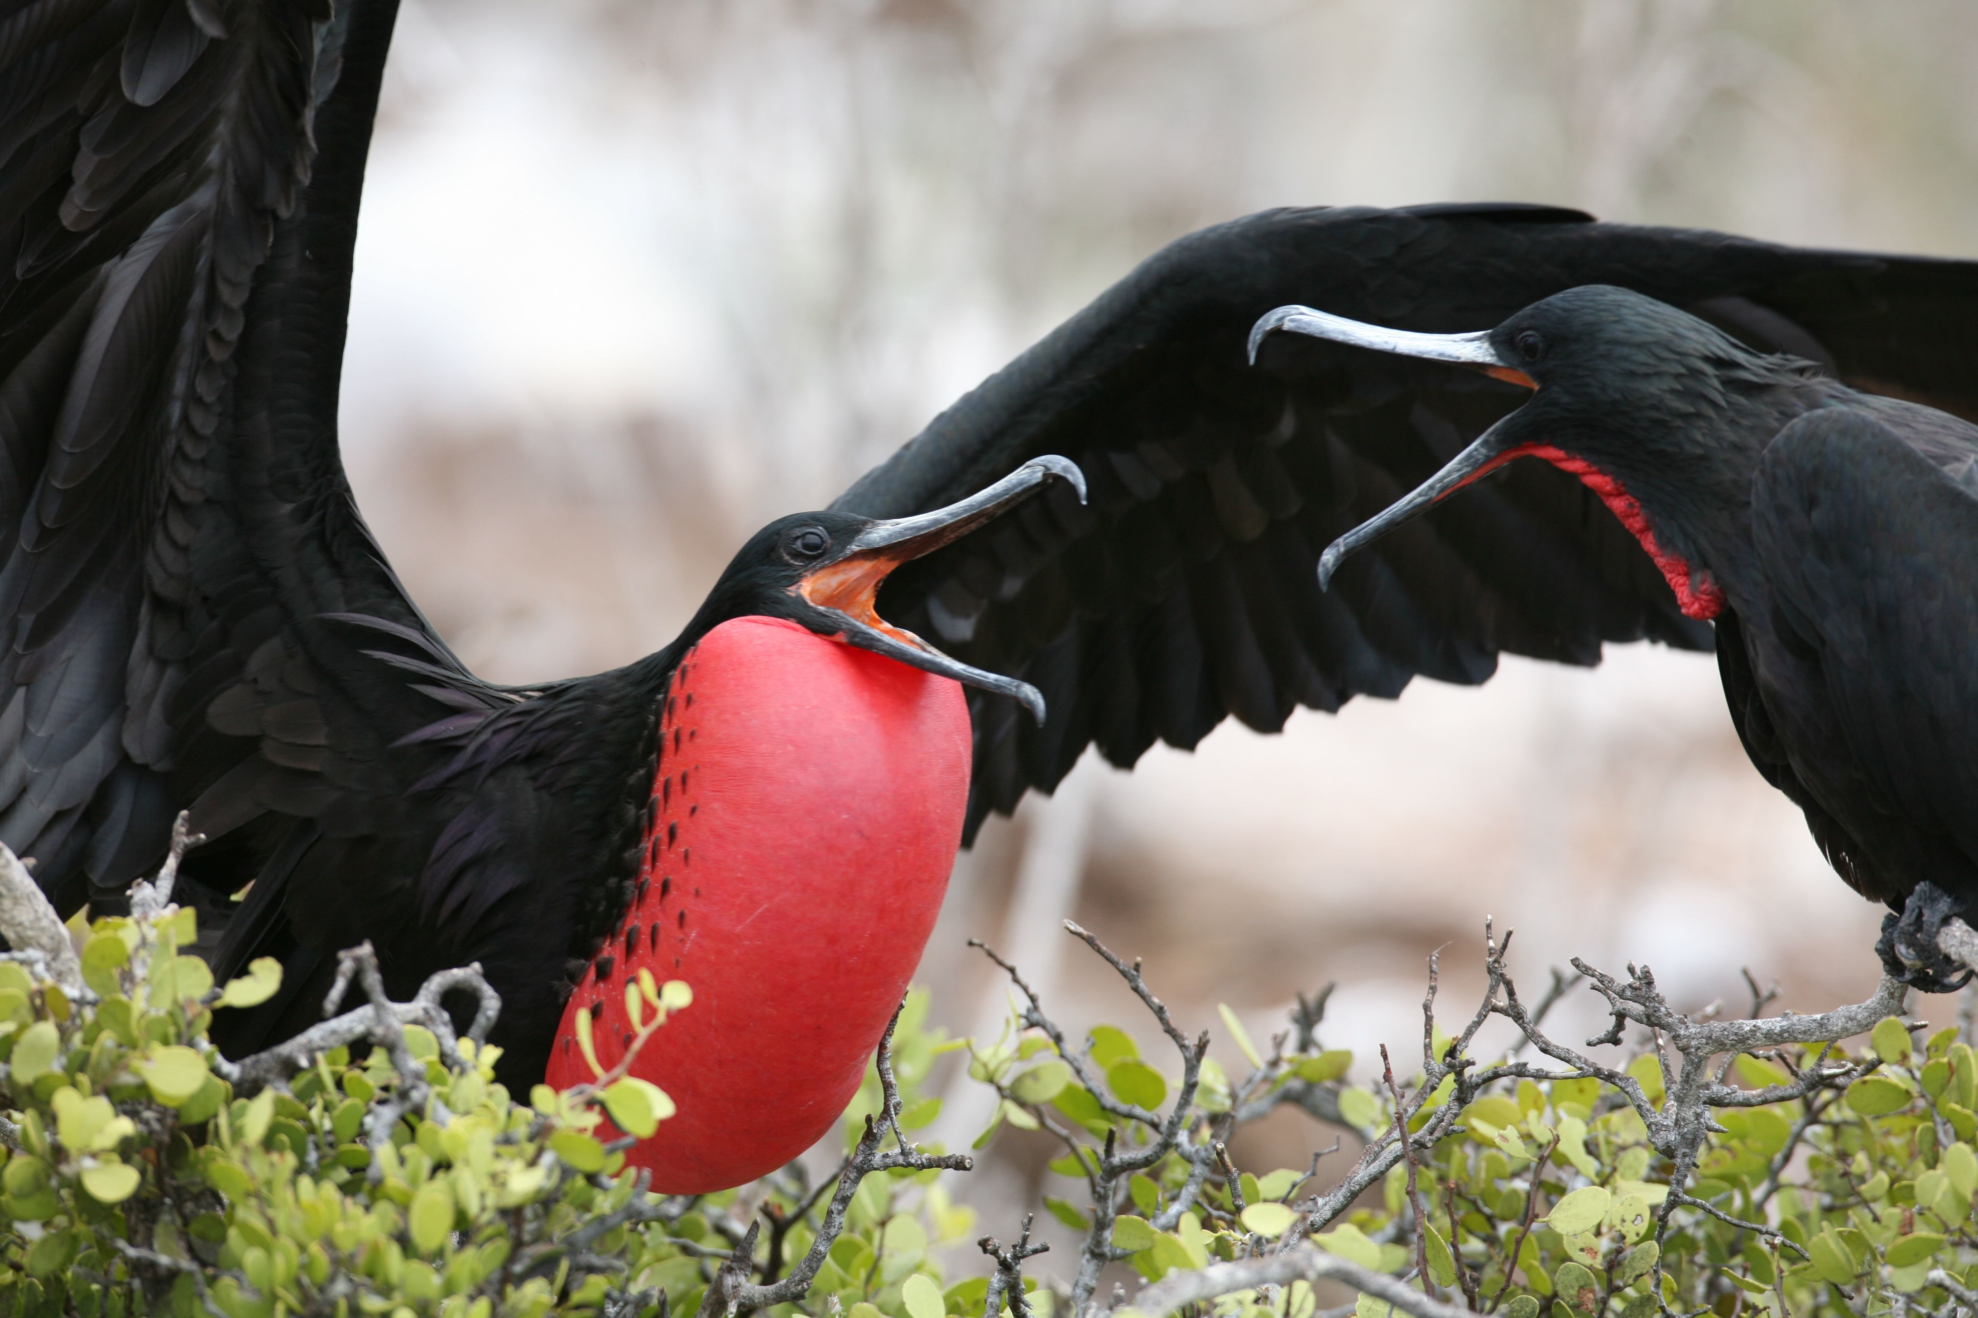
The cherry on top of any Ecuador visit is our 8-day-long Galapagos cruise, which visits the best parts of the enigmatic archipelago. We have carefully selected the best available birding route to get the most out of it, so we visit several islands with numerous birding sites witnessing various landscapes and abundant wildlife. This is truly an ultimate nature experience, a dream of any nature enthusiast!
Please note that the programme of visiting different islands can be changed by local authorities without prior notice or due to weather changes!
Fact File
- 8 days cruising; - start and finish in Quito with a flight to/from Isla Baltra, Galapagos
- using a comfortable Galapagos cruise ship; discover the islands
Highlights
- visiting the 10 best spots of the Galapagos Islands
- wide variety of amazing birds, reptiles and mammals with great photo opportunities
Accommodation
2 nights at Quito, colonial capital
7 nights on board of a cruise ship, ideal for small groups; 1 overnight flight
Itinerary
1 Arrival to Quito, short transfer to the hotel. Vermillion Flycatcher, Rufous-collared Sparrow, Black-tailed Trainbearer, Sparkling Violet-Ear.

2 Fly to Isla Baltra, transport to Santa Cruz Island
Sea turtles, Flamingos, Black-necked Stilt, Whimbrel
3 Plazas Islands & Santa Fe (Barrington) Island: land iguanas, sea lions, Swallow-tailed Gull, Audubon’s Shearwater, Red-billed Tropicbird, Magnificient Frigatebird, Brown Pelican
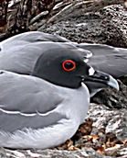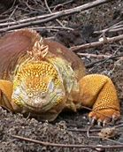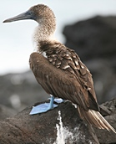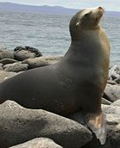
4 | Espanola/Hood Island ; Punta Suarez  Waved Albatross, Masked and Blue-footed Boobies, Hood Mockingbird, Warbling Finch, Galapagos Hawk, Large Cactus Finch, Swallow-tailed Gull, Red-billed Tropicbird
5 | Santa Maria/Floreana Island best flamingo lagoon, Black-necked Stilt, White-cheeked Pintail, Willet, Wimbrel
6 | Santa Cruz Island Charles Darwin Interpretation Center with Galapagos Tortoises Highlands of Santa Cruz.
7 | Rábida/Jervis Island White-cheeked Pintail  Bartolome Galapagos Penguins
8 | Genovesa/Tower Island is only included in some of the cruises. Colonies of Red-footed and Masked Boobies, Swallow-tailed Gulls, Red-billed Tropicbirds, Great Frigatebirds, Wedge-rumped Storm Petrels, Galapagos Doves, Short-eared Owl, Large Cactus-Finch, Sharp-beaked Ground-Finch
9 | North Seymour Island Magnificent Frigatebirds, Blue-footed Boobies, sea lions  Mosquera Islet sea lion, Lava heron, Lava Gull  Ttransfer to Isla Baltra’s airport for our flight back to Quito where we spend 1 night.  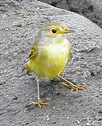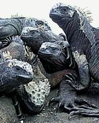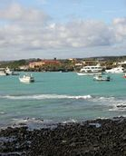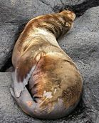
10 | Flight back to London or continue on our Ecuador Highland Special tour. Depending on the flight schedule there is a possibility of a last morning birding by visiting a nearby volcano to search for local species or look around in the colonial centre of the capital city.
11 | Overnight flight, arrival home.
Put together your own group and receive significant discounts!
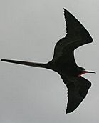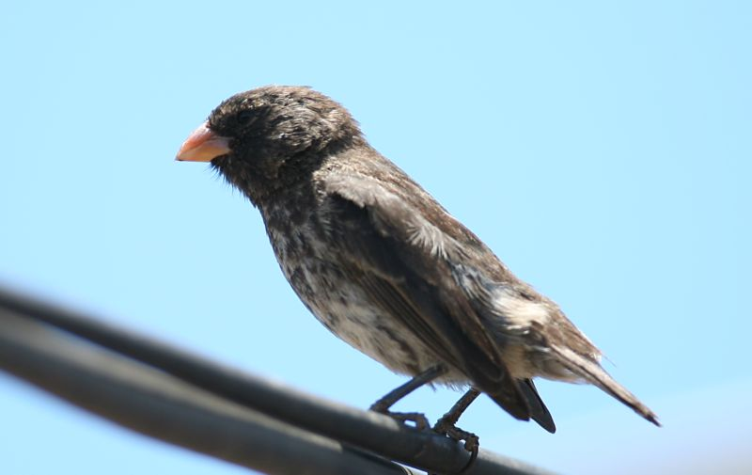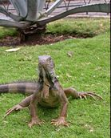
Please note that the route of the cruise can be changed without advanced notice! Deadline for signup and payment is different from other tours.
The Highland Special; NW & East Cordilleras
Ecuador, 9 days
Put together your own group and receive significant discounts!

Nowhere else on earth can you find such a high biodiversity in such a small place like Ecuador. Although it is the second smallest country in South America it boasts of an extraordinary richness of birds, well over 1600 species. Birding is easy and relaxed thanks to short distances, comfortable lodges and an incredible abundance of species. Colourful Hummingbirds, Tanagers, Toucans, Trogons, Quetzals, Barbets, Motmots, Cotingas abound in the Highlands, while secretive and mythical Antpittas, Ant-thrushes, Woodcreepers and Tapaculos are also seen in mixed feeding flocks in the cloud forest. Enigmatic species such as Andean Cock-of-the-Rock, hiding Oilbird, highly specialized Torrent Duck or several species of Antpittas can also be found. We hope to see at least 400 species during our relaxed holiday.

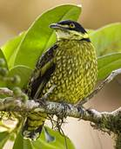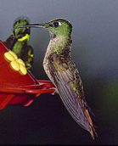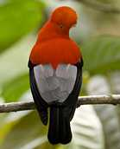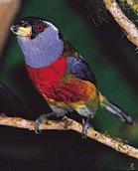

Fact File
- 9-day land tour of NW and East Cordilleras, - start and finish in Quito, colonial capital,
- using just 3 accommodations to maximize visited habitats and possible species
Highlights
- close to 1600 bird species out of which we hope to get around 1 quarter of it
- incredible variety of habitats from Pacific coast through temperate subtropical forest up to the Paramo of the Andes dotted with high volcanoes and down to tropical rainforests
- 4-500 bird species, up to 70 tanagers, 60 hummingbirds, Toucans, Trogons, Quetzals, Barbets, Tapaculos, Andean Cock-of-the-Rock, Oilbird, Torrent Duck, Antpittas
Accommodation
2 nights (1st and 7th) at Quito; 3 nights at Bellavista, NE Cordilleras
2 nights at San Isidro or Guango Lodge, Eastern Cordilleras; 1 overnight flight
Itinerary
Arrival to Quito, transfer to hotel. Vermillion Flycatcher, Rufous-collared Sparrow, Black-tailed Trainbearer and Sparkling Violet-Ear.
NW Highlands: Yanacocha area and Nono Road Empress Brilliant, Collared and Brown Inca, Green-fronted Lancebill, Booted Racket-tail, Hoary, Golden-breasted and Black-breasted Puffleg, Undulated and Rufous Antpitta, Andean Guan, Bar-bellied Woodpecker, Barred Fruiteater, Rainbow-bearded, Thornbill and Black-chested Mountain-Tanager, Torrent Duck, Fasciated Tiger-Heron, Plain-breasted Hawk, Black-chested Buzzard Eagle, Black-and-chestnut Eagle and Ornate Hawk-Eagle, Common Potoo, Lyre-tailed or Swallow-tailed Nightjar and Rufous-bellied Nighthawk.
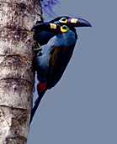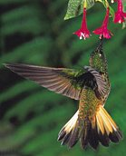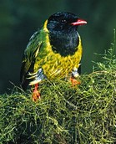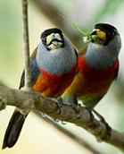
Bellavista Toucan Barbet, Masked Trogon, Plate-billed Mountain Toucan, Metallic Green, Flame-faced, Silver-throated, Grass Green, Orange-eared, Golden-naped, Fawn-breasted, Blue-capped and Blue-winged Mountain Tanager. Hummingbird feeders attract Brown & Collared Inca, Tawny-bellied Hermit, Green & Sparkling Violetears, Western & Andean Emeralds, Fawn-breasted Brilliant, Speckled Hummingbird, Buff-tailed Coronet, Gorgeted Sunangel, Purple-bibbed Whitetip, Booted Racket-tail & Purple-throated & White-bellied Woodstars. Beautiful Jay, White-faced Nunbird, Chestnut-crowned & Giant Antpitta, Ocellated Tapaculo, Golden-headed & Crested Quetzal, Plushcap, Tanager Finch, Andean Cock-of-the-Rock, Spillman’s & Narino Tapaculos, Green-and-black Fruiteater, Tri-coloured Brush-Finch, Southern Yellow Grosbeak, Long-tailed Antbird, Olivaceous Piha, Turquoise Jay, Masked & White-sided Flowerpiercers, Andean Solitaire, Black-crested & Three-striped Warblers, White-tailed & Rufous-winged Tyrannulets
Mindo Valley Giant Antpitta, Velvet-Purple Coronet, Rufous-breasted Ant-thrush, Long-wattled Umbrellabird, Club-winged Manakin, Scaled Fruiteater, Yellow-collared Chlorophonia, Toucan Barbet, Choco Toucan, Golden-headed Quetzal, Crimson-rumped Toucanet, Pale-mandibled Aracari & Flame-faced, Golden-naped, Golden, Black-capped & Beryll-spangled Tanagers
Milpe Choco Toucan, Choco Screech-Owl, Choco Trogon
Los Bancos Guayaquil Woodpecker, Pacific Hornero, Moss-backed Tanager, Pale-mandibled Aracari.
Bellavista and Alambi, finally we arrive to San Isidro, Eastern Cordilleras.
Antisana volcano Andean Condor, Carrunculated Caracara, Andean Lapwing, Aplomado Falcon, Andean Gull, Ecuadorian Hillstar & Black-billed Shrike-Tyrant
Papallacta Pass Noble Snipe, Rufous-bellied Seedsnipe & Tawny Antpitta Guango and San Isidro Scarlet-bellied, Lacrimose, Buff-breasted & Hooded Mountain-Tanagers, Grey-hooded Bush-Tanager, Mountain Velvetbreast, Sword-billed Hummingbird, Tourmaline Sunangel, Mountain Avocetbill, Golden-breasted & Glowing Pufflegs, White-bellied & Gorgeted Woodstars.
Capped Conebill, Lacrimose Mountain-Tanager, Plain-tailed Wren, Chestnut-bellied Thrush, Rufous-breasted Flycatcher, White-bellied Antpitta, White-capped Tanager, White-rimmed Brush-Finch, Blackish, Rufous-breasted Chat-Tyrant, Ash-coloured & Equatorial Rufous-vented Tapaculos, Smoky Bush-Tyrant, Rufous-crowned Tody-Tyrant Finally we return back to Quito for one night.
We return to Quito airport for your flight back home. Overnight flight, arrival home

Put together your own group and receive significant discounts!
